RESEARCH ARTICLE |  | 
JPSL Article Template v0124 (Calibri 14.5 pt bold Justify) Capitalized Each Word
Author Full Nameª, Author Full Name^{b}, Author Full Name^{b}
ª Department of xx, Faculty of yy, University of zz, City, Postal Code, Country
^{b} Department of xx, Faculty of yy, University of zz, City, Postal Code, Country

Article History
Received 00 January 20xx
Revised 00 January 20xx
Accepted 00 January 20xx

Keywords
keyword entry 1, keyword entry 2, keyword entry 3



ABSTRACT (Max 250 words)
Insert abstract text here. Abstract is written in English, containing no more than 250 words. The abstract briefly presents the important introduction, research objectives, methods, major findings, and main conclusions. Please avoid writing the abbreviation of an acronym in the abstract. Keywords are important to the significance and implications of research findings and should also be listed in the abstract. Abstracts should contain quantitative results. Do not write any citation in the abstract. Every article submitted to a journal editorial must follow these writing guidelines. If the article does not comply with this guidance, the article will be returned before further review. Lorem ipsum dolor sit amet, consectetuer adipiscing elit. Maecenas porttitor congue massa. Fusce posuere, magna sed pulvinar ultricies, purus lectus malesuada libero, sit amet commodo magna eros quis urna. Nunc viverra imperdiet enim. Fusce est. Vivamus a tellus. Pellentesque habitant morbi tristique senectus et netus et malesuada fames ac turpis egestas. Proin pharetra nonummy pede. Mauris et orci. Aenean nec lorem. In porttitor. Donec laoreet nonummy augue.

Introduction (word style: JPSL Heading 1)
This is the main text of the manuscript in JPSL (Word style: JPSL Article text). Use Calibri 10 pt font style and size for the main body, with single space. The manuscript should be written in English. For full instructions, please see the journal’s Instructions for Authors. Do not modify the font in this or any other section, as doing so will not give an accurate estimate of the formatting for publication and the final length of the paper. One paragraph should consist of 4–5 sentences. Sentences containing more than 30 words are recommended to be split into two or more shorter sentences to improve readability.
The "Introduction" section of a scientific paper serves as the manuscript's opening and plays a crucial role in setting the stage for the research study. Its primary purpose is to provide essential background information, establish the context and significance of the study, articulate the research problem or question, and outline the objectives and hypotheses of the research. This section serves as a bridge between the existing body of knowledge and your research. It should be designed to grab the reader's attention, convey the importance of your study, and motivate them to continue reading to learn more about your research findings and conclusions.
Lorem ipsum dolor sit amet, consectetuer adipiscing elit. Maecenas porttitor congue massa. Fusce posuere, magna sed pulvinar ultricies, purus lectus malesuada libero, sit amet commodo magna eros quis urna. Nunc viverra imperdiet enim. Fusce est. Vivamus a tellus. Pellentesque habitant morbi tristique senectus et netus et malesuada fames ac turpis egestas. Proin pharetra nonummy pede. Mauris et orci. Aenean nec lorem. In porttitor. Donec laoreet nonummy augue. Suspendisse dui purus, scelerisque at, vulputate vitae, pretium mattis, nunc. Mauris eget neque at sem venenatis eleifend. Ut nonummy. Fusce aliquet pede non pede. Suspendisse dapibus lorem pellentesque magna. Integer nulla. Donec blandit feugiat ligula. Donec hendrerit, felis et imperdiet euismod, purus ipsum pretium metus, in lacinia nulla nisl eget sapien.
Materials and Methods
This is Heading 2 (Word style: JPSL Heading 2)
Materials and methods section is a crucial component that provides a detailed description of the experimental design, procedures, and techniques used to conduct the research. This section aims to allow other researchers to replicate the study and verify its findings. This section typically includes experimental design, study location, materials, sample or study subject, experimental procedures, data collection, data analysis, replication, etc. Remember that the level of detail and organization within the "Materials and Methods" section should be sufficient for another scientist in your field to replicate your study and obtain similar results. Clarity, precision, and transparency are key principles when writing this section.
Examples of good map for the manuscript
Displaying the study location map in a scientific paper is essential for providing context and helping readers understand the geographical scope of your research. Elements of the map should be included: Inset (overview map), Scale bar (without numeric), Legend, Direction, and Map Annotation. Use high-resolution images (minimum 400 dpi) to maintain the map's clarity and quality, even when resized. For other examples, please download it here. Avoid university logos, creator names, excessive legends, and numeric scales, as they resemble printed map formats; must use bright colors. All text within figures should use Calibri font, size 10 pt.
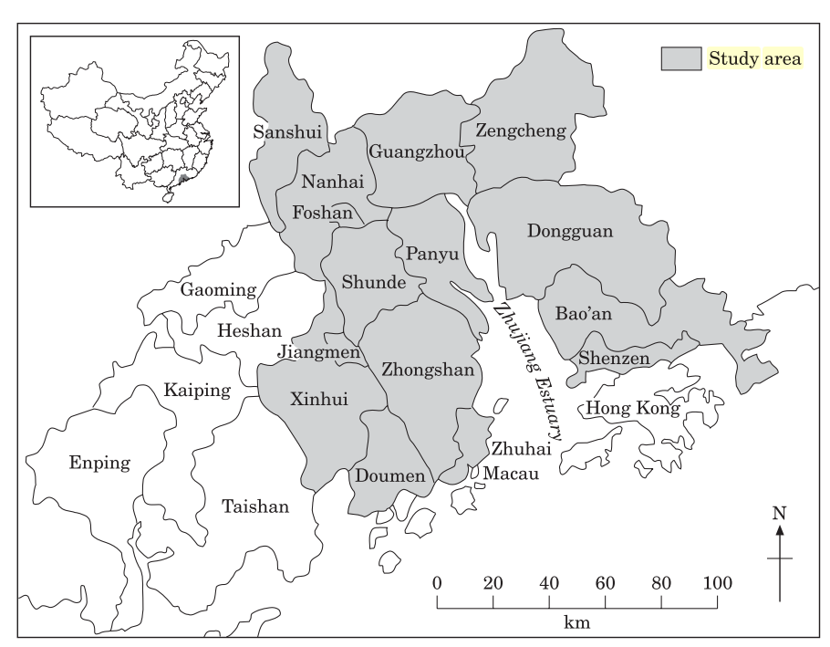
Figure 1. An exemplary illustration for a scientific paper is a map that strikes a balance between simplicity and informativeness, helping readers understand. Elaborate maps with headers, often printed in larger dimensions, are unsuitable for scientific papers, given that they will be presented in reduced dimensions on the page.
Figures and Illustrations
Presenting figures and illustrations effectively in a scientific paper is crucial for conveying information clearly and enhancing the reader's understanding. Each figure or illustration must have a caption that includes the figure number and a brief description, preferably one or two sentences. The caption should follow the format “Figure 1. Figure caption”. All figures must be mentioned in the text consecutively and numbered with Arabic numerals. The caption should be understandable without reference to the text. Whenever possible, place the key to symbols in the artwork, not in the caption. To insert the figure into the template, ensure it is appropriately sized, then paste it before the figure caption. We need the figures that contain all legend and attributes to be together in a single file and not separated and not use any text box to combine the figures. Save as or convert the images to JPG: Color or grayscale photographs (halftones): always use a minimum of 400 dpi. The font and size must be consistent. Please identify the pictures in the manuscript by bracketed lowercase letters (e.g. (a), (b), (c)….).
Figures should fit well within the paper's page layout, neither cramped nor overly large. They should complement the text rather than dominate it. Please ensure that every figure/table title/caption is self-explanatory and can stand alone without referring to the main text. Each Figure caption should contain two concise, informative, and self-explanatory sentences that enable readers to understand the table without referring extensively to the main text. The first sentence should describe the content or key elements displayed in the figure, including relevant context (e.g., location, time, or measured variables). The second sentence should highlight the main message, trend, or key finding illustrated by the figure, allowing the caption to be understood independently without referring to the main text.

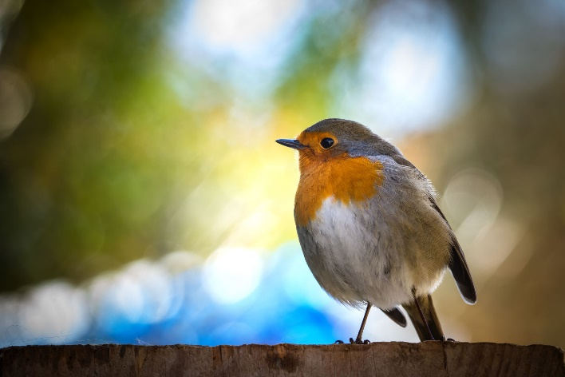
Figure 2. Provide a brief description of the image in one or more sentences using Calibri 10 pt font and create captions using the Microsoft Word "Insert Caption" feature rather than manually. Align single-line captions with the regular paragraph margin and multi-line captions to the left page margin, and include proper source attribution, permissions, and credits for any adapted or modified figures.
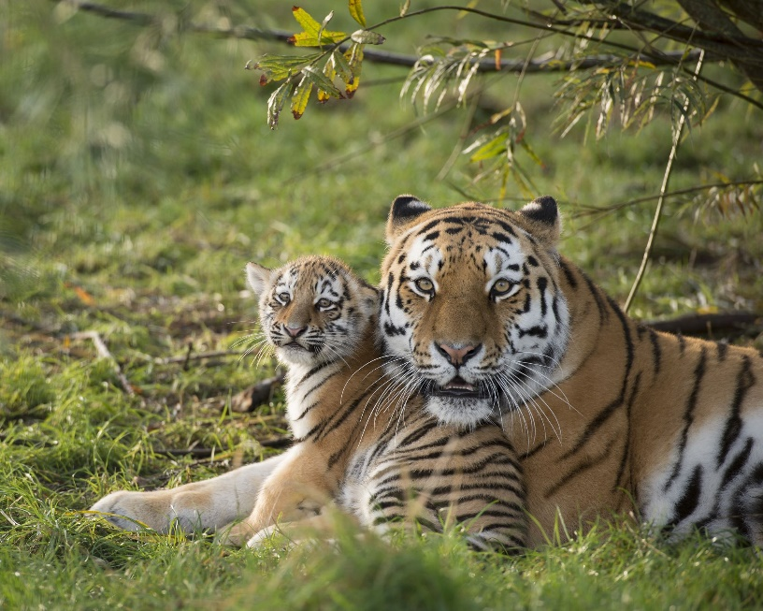
Figure 3. A mother tiger rests on the grass, her cub nestled close beside her, highlighting the strong maternal bond and the early-stage dependency of young individuals in their natural habitat. This scene illustrates the importance of secure, undisturbed forest environments for supporting breeding success and the survival of vulnerable tiger populations.

Figure 4. Another example of a figure in the form of a chart. If possible, the chart must be in an editable format and should not be presented as images. As the journal editor will modify it in camera-ready format. All text within figures should use Calibri font, size 10 pt. Numerical values should follow the formatting guidelines described in the ‘Equation and Numbers’ section of this template.
Tables
Presenting tables in a scientific paper is a systematic and organized way to present complex data, results, or comparisons. Tables should be presented without horizontal borders within the body, except for the header. They should also be without vertical borders, both inside and outside (see example in Table 1). Please avoid tables that overflow. However, if necessary, please ensure the header is repeated on every page. All tables must be in an editable format and should not be presented as images. Use 10 pt Calibri font for table content (Word style JPSL Table Body). Please refrain from making the header bold. Repeat the table header for the overflow table. Each table caption should contain two concise, informative, and self-explanatory sentences that enable readers to understand the table without referring extensively to the main text. The first sentence should describe the content or key elements presented in the table, including relevant context (e.g., location, time, or measured variables). The second sentence should highlight the main finding or key message presented in the table, allowing the caption to be understood independently without referring to the main text.

Table 1. Caption of a table (Word style: JPSL Caption of table). The font used is Cambria, size 10 pt. Please refrain from manually creating the figure caption; use the "Insert Caption" tool in Microsoft Word instead.
No. | Tree species | Family | Group | Feed distance (m)
1 | Ficus elastica | Moraceae | A | 0.0
2 | Sterculia macrophylla | Malvaceae | C | 9.0
3 | Octomeles sumatrana | Moraceae | C | 10.0
4 | Artocarpus elasticus | Tetramelaceae | C | 0.7
5 | Sterculia oblongata | Malvaceae | A | 0.0
6 | Pterospermum javanicum | Malvaceae | A | 7.0
7 | Schima walichii | Theaceae | D | 0.5
8 | Shorea sp.* | Dipterocarpaceae | D | 8.0
9 | Artocarpus elasticus | Moraceae | A | 0.0
10 | Ficus microcarpa | Moraceae | B | 0.0
11 | Sterculia macrophylla | Malvaceae | K | 0.0
12 | Pterospermum javanicum | Malvaceae | K | 4.0
13 | Dillenia sumatrana | Dilleniaceae | J | 0.0
14 | Litsea sp.* | Lauraceae | J | 4.5
* Note can be added, if necessary, at the bottom of the table. Consider adding note if you need to emphasize something in the table (Word style JPSL Table Footnote)
Equations and Numbers
All equations must be presented in editable text format rather than as images. The use of Microsoft Word’s equation tool is acceptable for formatting mathematical expressions. Equations should be numbered consecutively throughout the manuscript. Each equation number must appear in round brackets and be aligned to the right-hand side of the page. All equations should be cited in the main text using the format “Equation 1”, “Equation 2”, and so forth.
$x=\frac{-b±\sqrt{b^{2}-4ac}}{2a}$ (1)
A decimal numeral is expressed using a period (.), as seen in 20.19. The thousand separator is a comma (,), such that thirty thousand is written as 30,000. The percentage numeral (%) is devoid of spaces, as demonstrated by 100%. Indicating units adhere to established conventions, such as g m⁻², m³ day⁻¹, 30°C year⁻¹, and so on. For multiplication operations, authors should use the multiplication symbol (×) instead of the letter "x" to avoid ambiguity. In instances involving multiple mathematical equations, numbering should be applied consecutively.
    - This is Heading 3 (Word style: JPSL Heading 3)
Lorem ipsum dolor sit amet, consectetur adipiscing elit, sed do eiusmod tempor incididunt ut labore et dolore magna aliqua. Ut enim ad minim veniam, quis nostrud exercitation ullamco laboris nisi ut aliquip ex ea commodo consequat. Duis aute irure dolor in reprehenderit in voluptate velit esse cillum dolore eu fugiat nulla pariatur. Excepteur sint occaecat cupidatat non proident, sunt in culpa qui officia deserunt mollit anim id est laborum. Therefore, the discussion highlights the importance of maintaining coherence and continuity throughout the paragraph to effectively communicate the main idea.
Results and Discussion
Results
Please note that the Results and Discussion must be presented as separate sections. What is included in the results section? The results section should include your study's findings and ONLY yours. The findings include data presented in tables, charts, graphs, and other figures (which may be placed in the text or on separate pages at the end of the manuscript). The results section should include your study's findings and ONLY yours. The findings include: 1) Data presented in tables, charts, graphs, and other figures (may be placed into the text or on separate pages at the end of the manuscript); 2) A contextual analysis of this data explaining its meaning in sentence form (describe in paragraphs); 3) All data that corresponds to the central research question(s); 4) All secondary findings (secondary outcomes, subgroup analyses, etc.).
Manuscripts submitted to JPSL must comply with the journal’s standards for originality and research integrity. The AI writing score and similarity index of the manuscript must each be below 20% in accordance with JPSL requirements. Authors are also expected to ensure that all visual materials accurately represent the original research outputs. Figures and tables generated by artificial intelligence are not accepted for publication. Instead, all figures and tables should be produced directly from the primary tools, software, or analytical methods used in the study.
Discussion
A discussion paper is an academic document designed to examine a specific topic or issue in depth. It presents and evaluates multiple perspectives, arguments, and theoretical approaches related to the subject under consideration. The paper may also analyze and compare relevant evidence, data, or viewpoints to provide a balanced and comprehensive understanding of the issue. Through this analytical process, it highlights key areas of agreement, disagreement, and uncertainty within the existing body of knowledge. Ultimately, the primary purpose of a discussion paper is to stimulate critical thinking and informed debate, enabling readers to develop their own well-reasoned conclusions.
Conclusions
The conclusion section should be placed at the end of the article, immediately before the acknowledgments. It must be written in narrative form rather than as bullet points and presented as a single coherent paragraph. The conclusion should directly address the research objectives or hypotheses by providing an interpretation or response to the issues examined in the study. Rather than summarizing the research findings, it should emphasize the broader meaning and implications of the results. Overall, the conclusion should be concise, clear, qualitative in nature, and capable of offering a broad perspective on the research topic.
Author Contributions
We strongly encourage authors to include author contributions and recommend using CRediT for standardised descriptions of contributions. Authors’ names are written in their initials and bold, and can be found at https://credit.niso.org/

Example:
MRM: Conceptualization, Methodology, Software, Investigation, Writing - Review & Editing; NN: Writing - Review & Editing, Supervision; TVZ: Writing - Review & Editing, LS: Writing - Review & Editing, and LU: Writing - Review & Editing.
AI Writing Statement
Manuscripts submitted to JPSL must comply with the journal’s standards for originality and research integrity. The AI writing score and similarity index of the manuscript must each be below 20% in accordance with JPSL requirements. Authors are also expected to ensure that all visual materials accurately represent the original research outputs. Figures and tables generated by artificial intelligence are not accepted for publication. Instead, all figures and tables should be produced directly from the primary tools, software, or analytical methods used in the study.

Declaration of Generative AI and AI-assisted technologies in the writing process.
Authors must disclose the use of generative AI and AI-assisted technologies in the writing process. AI should not be used for key researcher tasks such as interpreting data or drawing scientific conclusions.

- When AI-assisted technologies were used in the writing process, use the following statement: During the preparation of this work, the author(s) used [NAME TOOL / SERVICE] to [REASON]. After using this tool/service, the author(s) reviewed and edited the content as needed and take(s) full responsibility for the content of the publication.
- When AI-assisted technologies were not used in the writing process, use the following statement: ‘The authors did not use any artificial intelligence-assisted technologies in the writing process’.

Conflicts of interest (Word style JPSL Heading 1 without number)
Following our policy on conflicts of interest, please include a conflict of interest statement in your manuscript here. Please note that this statement is required for all submitted manuscripts. If no conflicts exist, please state, "There are no conflicts to declare.”
Acknowledgments
The acknowledgments come at the end of an article after the conclusions and before the notes and references.
Citation
We use citation style from the Multidisciplinary Digital Publishing Institute (MDPI). All citations in the text must be numbered consecutively in square brackets before any punctuation, for example, “as discussed by Prasetyo et al. [1], ……” or “NDVI derived from a multispectral sensor on UAV is accurate with high determination values compared to the direct measurement [2]”. Please ensure that citations are numbered sequentially without skipping any numbers. All references listed in the References section must be cited in the manuscript, and all in-text citations must appear in the References section.
References
We encourage citing primary research over review articles, where appropriate, to credit those who first reported a finding. Authors are responsible for ensuring that the information in each reference is complete and accurate. Minimum 30 with a portion of 60% international journal, 30% national journal, 5% proceedings, and 5% other sources. Please ensure that every reference cited in the text is also in the reference list (and vice versa). Please be note that manuscripts should usually contain at least 30 references and some of them must be up-to-date research articles. We recommend the author use Mendeley reference manager software to create the reference list. Most of the references are primary ones (last five years). The reference lists should be ordered based on their appearance in the main text.) The reference list will be formatted according to the MDPI Remote Sensing style. You may download the citation style for Mendeley and Zotero from these links:
Mendeley: https://csl.mendeley.com/styleInfo/?styleId=http%3A%2F%2Fwww.zotero.org%2Fstyles%2Fremote-sensing
Zotero: https://www.zotero.org/styles/multidisciplinary-digital-publishing-institute
The reference list should be like this:

References (Word style JPSL Reference list heading)
1. Prasetyo, L.B.; Nursal, W.I.; Setiawan, Y.; Rudianto, Y.; Wikantika, K.; Irawan, B. Canopy Cover of Mangrove Estimation Based on Airborne LIDAR &amp; Landsat 8 OLI. IOP Conf. Ser. Earth Environ. Sci. 2019, 335, 012029, doi:10.1088/1755-1315/335/1/012029.
2. Fawcett, D.; Panigada, C.; Tagliabue, G.; Boschetti, M.; Celesti, M.; Evdokimov, A.; Biriukova, K.; Colombo, R.; Miglietta, F.; Rascher, U.; et al. Multi-Scale Evaluation of Drone-Based Multispectral Surface Reflectance and Vegetation Indices in Operational Conditions. Remote Sens. 2020, 12, doi:10.3390/rs12030514.
3. Parker, C.; Scott, S.; Geddes, A. Snowball Sampling; SAGE Research Methods Foundations: London, UK, 2019; ISBN 978-1-5443-6218-2.
4. Lee, J.-Y.; Marotzke, J.; Bala, G.; Cao, L.; Corti, S.; Dunne, J.P.; Engelbrecht, F.; Fischer, E.; Fyfe, J.C.; Jones, C.; et al. Future Global Climate: Scenario-Based Projections and Near-Term Information. In Climate Change 2021 – The Physical Science Basis: Working Group I Contribution to the Sixth Assessment Report of the Intergovernmental Panel on Climate Change; Masson-Delmotte, V., Zhai, P., Pirani, A., Connors, S.L., Péan, C., Berger, S., Caud, N., Chen, Y., Goldfarb, L., Gomis, M.I., et al., Eds.; Cambridge University Press: Cambridge, UK, 2021; pp. 553–672, ISBN 9781009157889.
5. Siswanto, S. Extreme Precipitation in Urban Jakarta: Historical and Future Trends. Dissertation, Vrije Universiteit Amsterdam, Amsterdam, The Netherlands, 2023.
6. Balboni, C.; Berman, A.; Burgess, R.; Olken, B. The Economics of Tropical Deforestation. Available online: http://www.nber.org/papers/w31410 (accessed on 24 June 2026).
7. Ministry of Fisheries and Marine Affairs. Keputusan Menteri Kelautan dan Perikanan Republik Indonesia 18 Tahun 2022 tentang Kawasan Konservasi di Perairan di Wilayah Timur Pulau Bintan Provinsi Kepulauan Riau; Ministry of Fisheries and Marine Affairs Republic of Indonesia: Jakarta, ID, 2022;
8. Rahmawati, S.; Hernawan, U.E. Laporan: Pemantauan Kesehatan Terumbu Karang dan Ekosistem terkait di Kabupaten Bintan Tahun 2019; Pusat Penelitian Oseanografi-LIPI: Jakarta, ID, 2019;
9. Chum, O.; Philbin, J.; Zisserman, A. Near duplicate image detection: Min-Hash and tf-idf weighting. In Proceedings of the 19th British Machine Vision Conference (BMVC 2008), Leeds, UK, 1–4 September 2008; pp. 812–815.
10. Du, J.; Zhong, Z.; Shi, Q.; Cao, Y.; Yang, C.; Wang, L. A Review of Household Carbon Footprint: Measurement Methods, Evolution and Emissions Assessment. Carbon Footprints 2024 , 3 , 11, doi:10.20517/cf.2024.08.

